
CITY OF FULLERTON

DOWNTOWN RESTAURANT OVERLAY DISTRICT—
CITY REVENUES AND COSTS
FOLLOW-UP REPORT
DECEMBER 2007

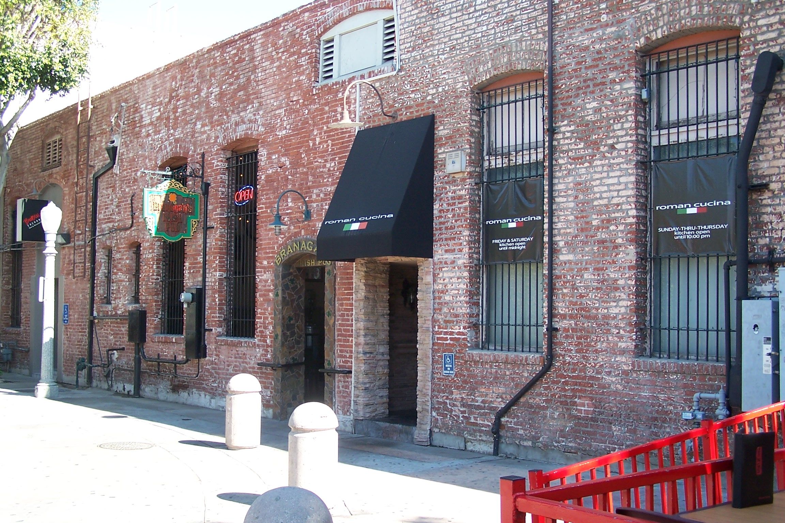
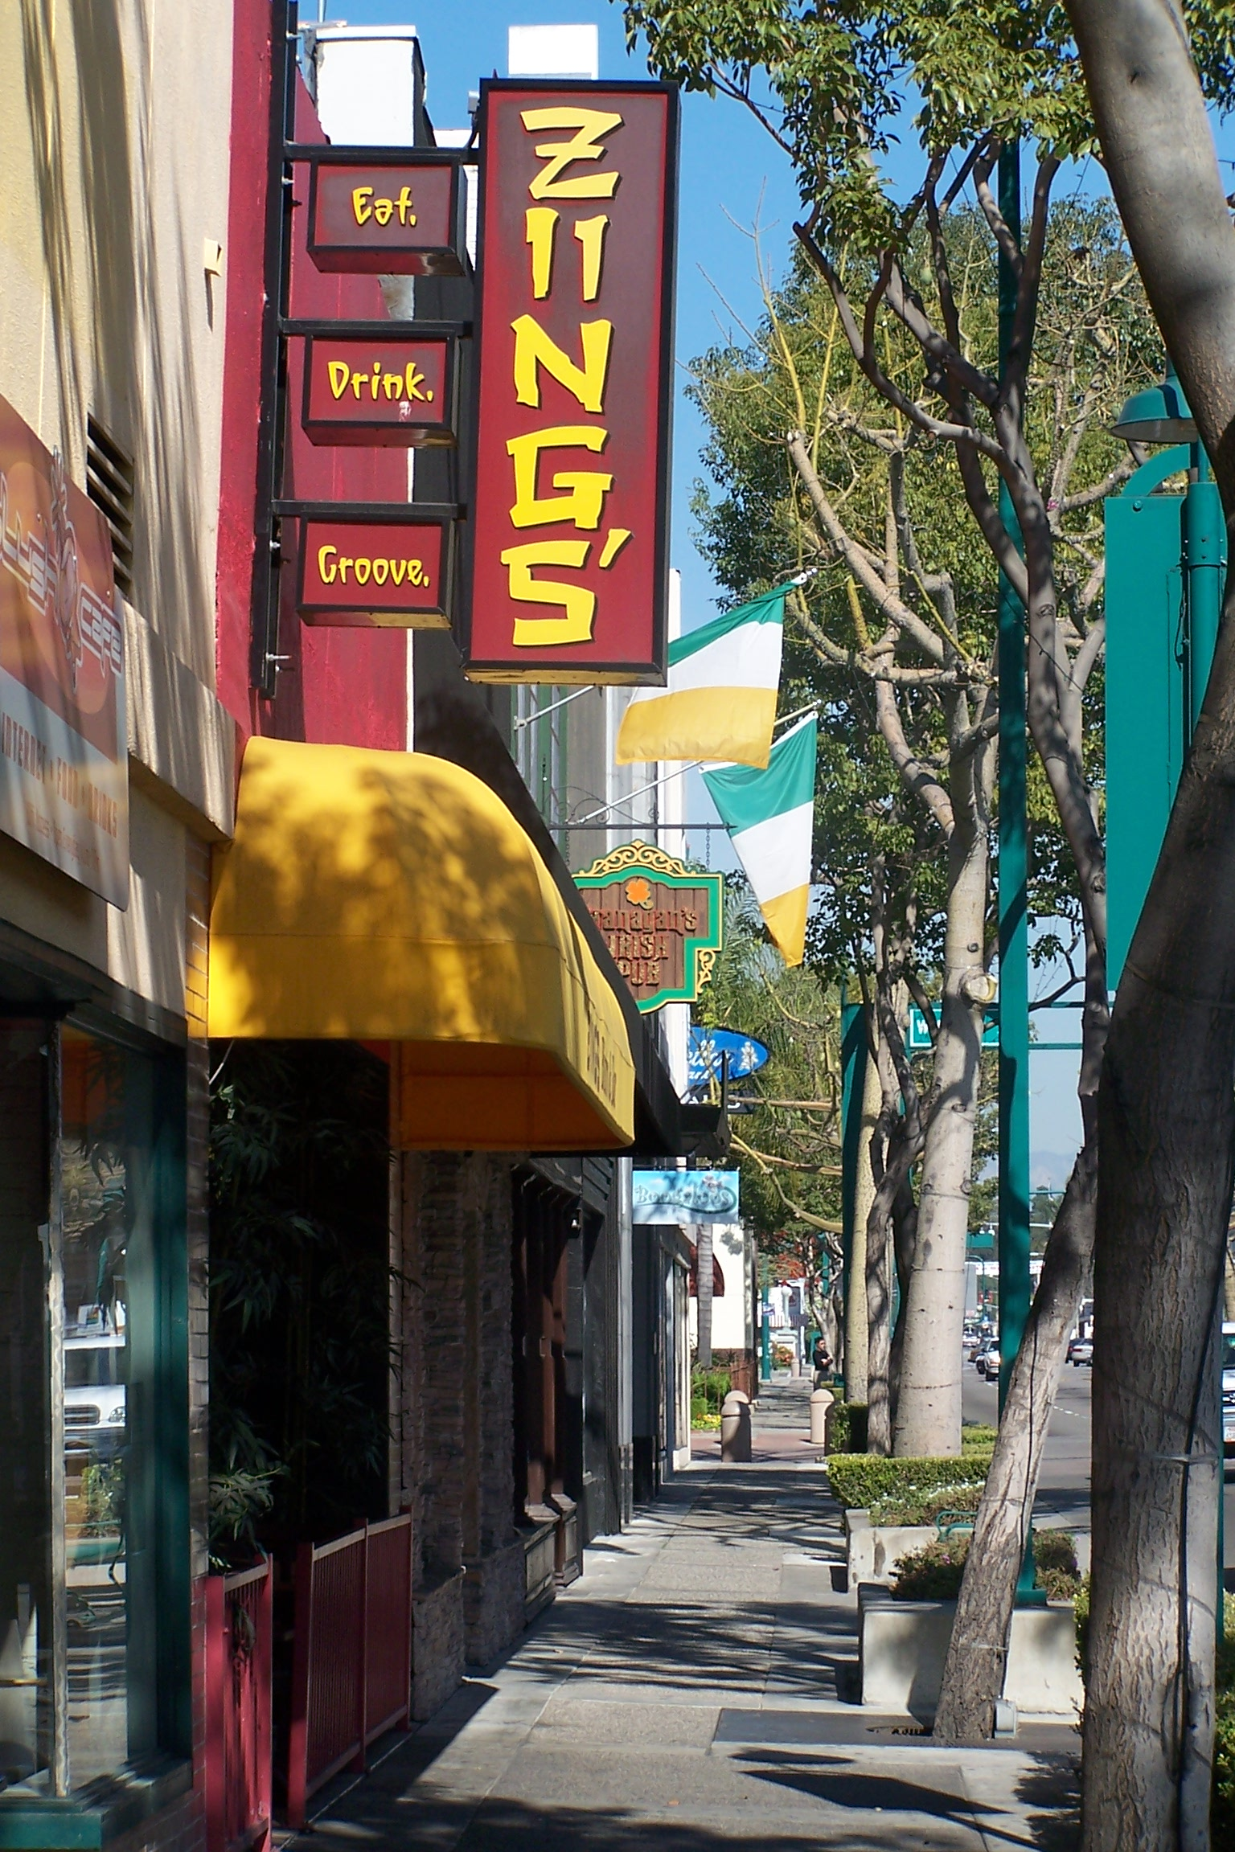
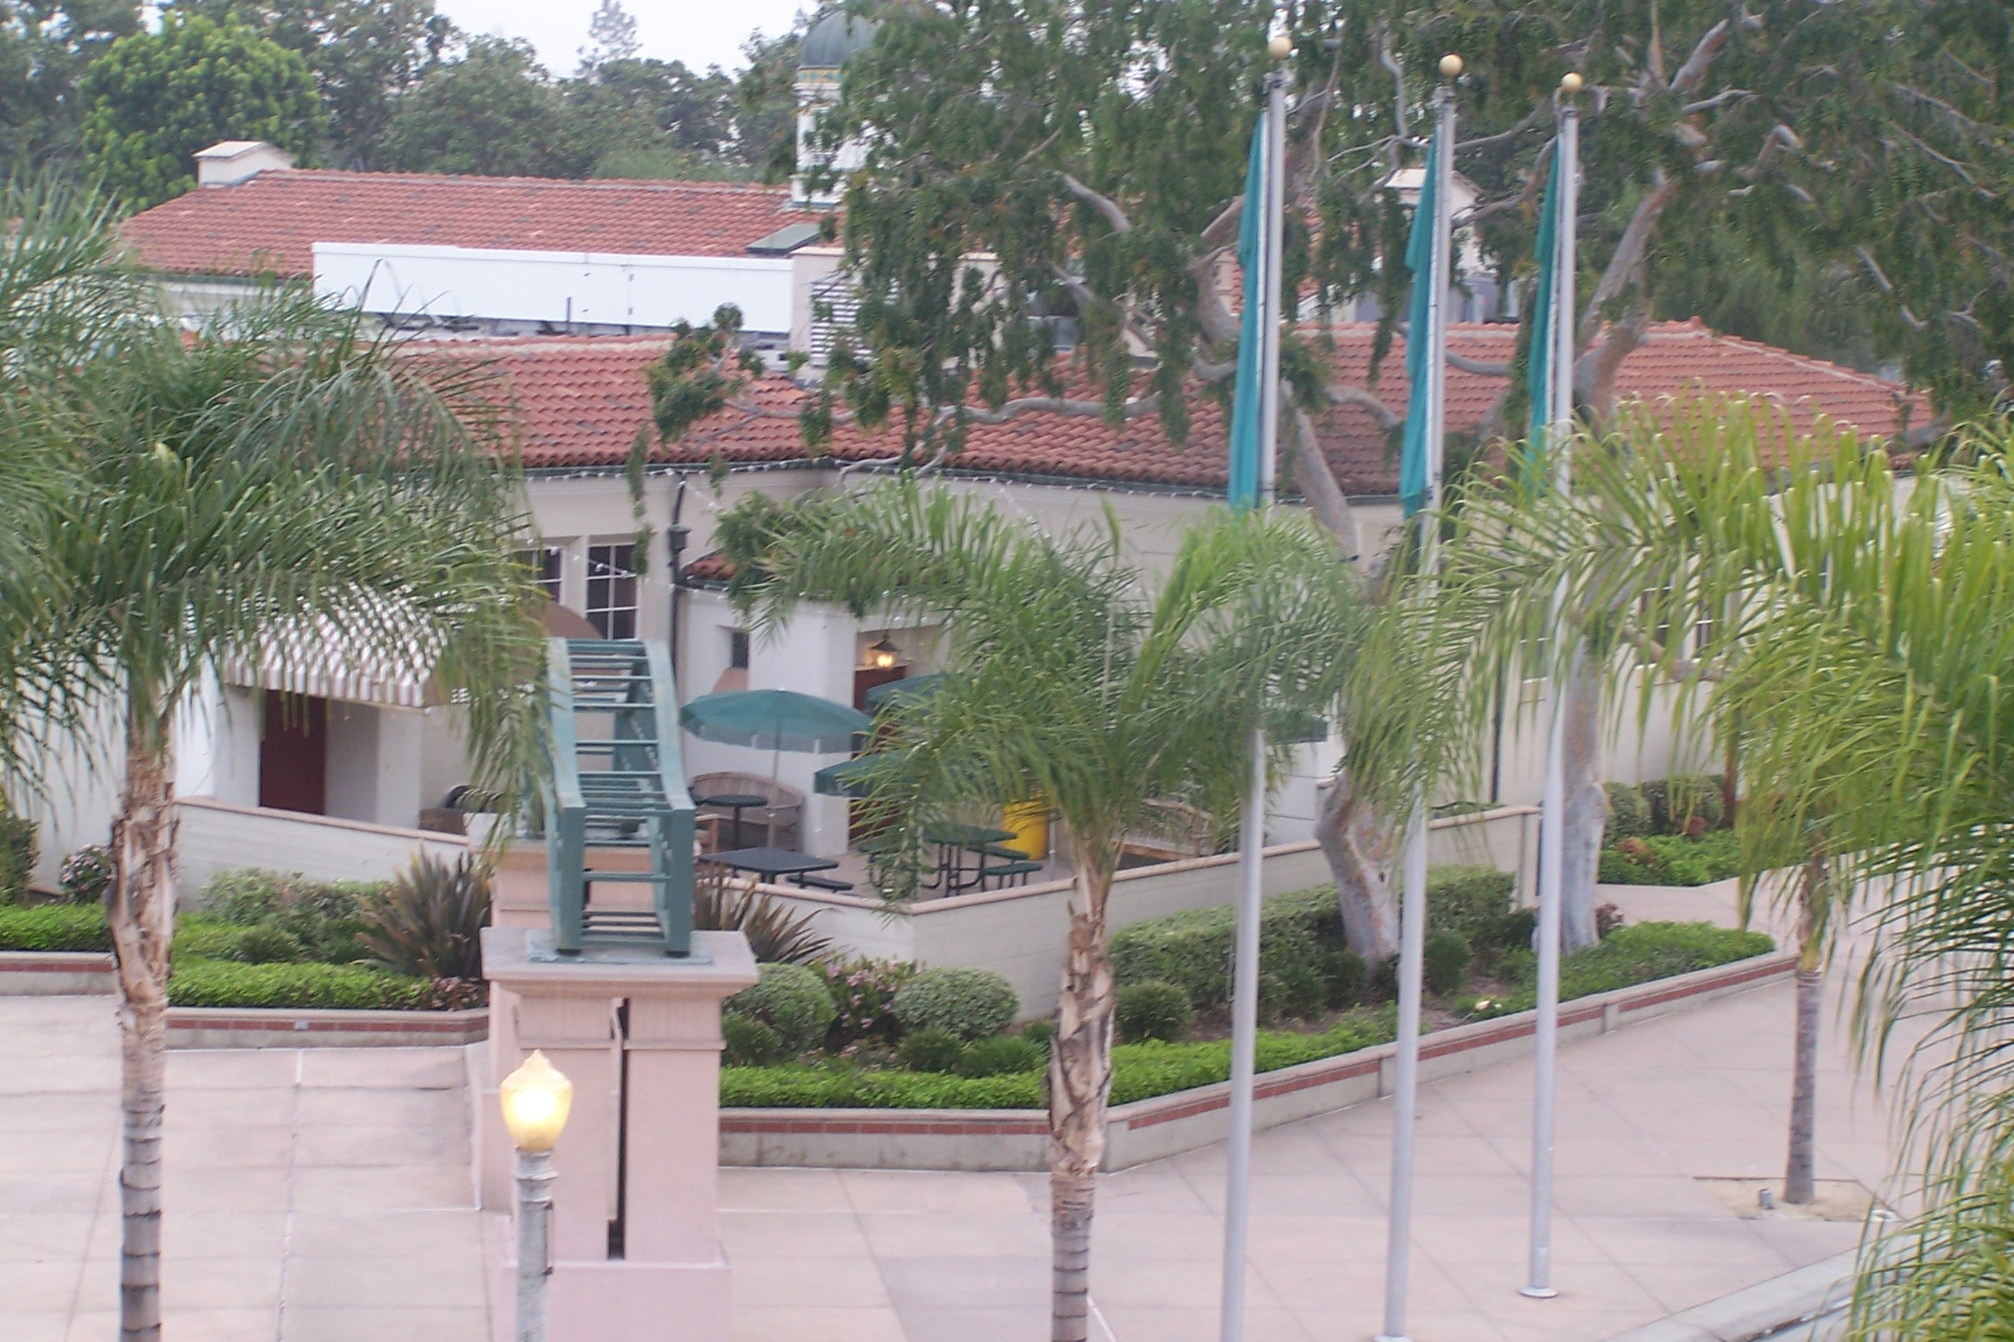

SECTION I. INTRODUCTION

In May 2007, Maintenance Services’ audit team was asked to prepare a report on the City’s costs and revenues in the Downtown Restaurant Overlay District (ROD). The report revealed the City was spending approximately $935,500 more than the revenue generated by the ROD. At the City Manager’s request, the audit team has updated the cost and revenue information for fiscal year 2007-2008.

SECTION II. PURPOSE

The purpose of this study is to update the costs and revenues reported in the initial Restaurant Overlay District study.

SECTION III. SCOPE

Since the purpose of this study is to update the revenues and costs reported in the May 2007 report, it will not go into detail as to how the audit team calculated the initial figures. The methodologies used in the first report are the same used in this update, except where noted. This follow-up will concentrate on the City’s three main cost centers: Police, Maintenance Services, and Fire.

SECTION IV. METHODOLOGY

The methods used in this study were applied in accordance with the United States General Accounting Office’s Generally Accepted Government Auditing Standards, 2003 revision.

For the sake of clarity, the terms “Restaurant Overlay District” and “downtown area” are used synonymously in this report, although he audit team realizes the two are not completely coterminous.

SECTION V. REVENUES

The May 2007 study estimated total City revenue from the ROD at $1,521,120 for fiscal year 2006-2007, with $413,790 (27%) attributable to restaurants. The revenue detail is shown in Table One:

Table One: Revenue Summary for FY 2006-07
Revenue Type | All District Businesses | District Restaurants
Sales Tax | 522,880 | 382,840
Property Tax | 954,630 | Unknown
Business Registration | 13,080 | 4,980
Fire Permits | 8,900 | 6,530
Engineering Fees | 21,630 | 19,440
TOTAL | 1,521,120 | 413,790

Of the $1,521,120, the Redevelopment Agency received $954,630 of the revenue. As mentioned in the original report, Redevelopment Agency revenue can be used for capital and other special projects, but not for operating costs. This left a net revenue to the City of $566,490.

The City’s Revenue Division was able to send the analysis team updated sales tax figures for the first two quarters of 2007. The team projected those figures for the remainder of the year. For the first two quarters, downtown sales tax revenue was $301,180. Projecting for the rest of the year, the team estimates 2007 revenue at $602,360. Actual 2006 revenue was $547,820, about $25,000 more than the original report projected. Therefore, sales tax revenues are projected to increase from $547,820 to $602,360, or about 10%.

Rather than re-analyzing every revenue stream, the audit team applied a straight-line inflationary factor of three percent to revenues other than sales tax. The result is an increase from $1,546,060 to $1,630,550 ($84,490), as shown in Table Two:

Table Two: Revenue Projections
Revenue Type | FY 2006-07 | Projected FY 2007-08
Sales Tax | 547,820 | 602,360
Property Tax | 954,630 | 983,270
Business Registration | 13,080 | 13,470
Fire Permits | 8,900 | 9,170
Engineering Fees | 21,630 | 22,280
TOTAL | 1,546,060 | 1,630,550

Overall revenue is projected to increase by five percent from fiscal year 2006-2007 to fiscal year 2007-2008. Assuming there has been no change to the division of revenue between the Agency and the City, the City’s net operating share of the $1,546,060 in total revenue would be 37%, or $572,040.

SECTION VI. COSTS

The City’s estimated annual costs in fiscal year 2006-2007 were $1,969,050, as shown in Table Three:

Table Three: One-Year Restaurant District Cost Summary
Department | Cost | Period
Police | 811,880 | FY 2006-07
Fire | 326,950 | CY 2006
Maintenance Services | 354,960 | FY 2006-07
Community Development | 8,200 | CY 2006
Engineering/CIP | 467,060 | FY 2006-07 (Average)
Total | 1,969,050

The costs in Table Three did not include two new programs scheduled for implementation in fiscal year 2007-2008: the addition of four Police Officers to patrol the downtown area, and a new pressure washing crew in Maintenance Services. To estimate the additional fiscal year 2007-2008 costs as accurately as possible, the audit team broke down the costs for each department.

VI-A: Police Department

In fiscal year 2006-2007, the Police Department incurred $811,800 in costs for operations in the downtown area. Applying the standard three percent inflation factor to that amount would result in a total for fiscal year 2007-2008 of $836,240. However, this cost does not account for the four new police officer positions and their vehicles. The total cost for four officers (salaries and benefits) should be $454,540 in fiscal year 2007-2008. The Police Department added at least one additional patrol vehicle, at a maintenance and replacement cost of $26,870, resulting in a total increase of $481,410. Based on the increase in existing costs, plus the addition of four officers, the team projected a total Police expense of $1,317,650 in fiscal year 2007-2008. The calculation is detailed in Table Four:

Table Four: Projected Police Costs
Cost Item | Amount
Patrol car | 26,870
4 Officers | 454,540
Projected FY 07-08 Base Costs* | 836,240
Total Projected FY 07-08 Costs | 1,317,650
*Base costs are FY 06-07 costs increased by 3%

VI-B: Maintenance Services

In the original study, the audit team estimated Maintenance Services costs at $354,960. This was before the last few months of fiscal year 2006-2007 had been completed. The department’s actual costs were substantially higher, at $471,020, a difference of $116,060. The difference can be attributed to the new pressure washing crew, added near the end of the year, plus increased maintenance activity during the longer and warmer days of the spring 2007.

The downtown area continues to place increasing demands on the Maintenance Services Department. Besides increased trash and grounds maintenance, the department added a two-person pressure washing crew just before the beginning of fiscal year 2007-2008. Using the department’s cost accounting system, the audit team was able to determine maintenance costs from July 1, 2007 through November 30, 2007 and then project those costs for the entire fiscal year. Through November, Maintenance Services spent $251,200 and dedicated 8,161 labor hours in the downtown area. If this trend continues through the remainder of the year, the department will have spent $602,930 and will have used 19,585 labor hours downtown. A comparison of actual fiscal year 2006-2007 costs and projected fiscal year 2007-2008 costs is shown in Table Five:

Table Five: Maintenance Costs FY 2006-07 & FY 2007-08
 | FY 2006-07 | FY 2007-08 | Increase
 |  |  | Amount | Percent
Labor Hours | 16,960 | 19,585 | 2,625 | 15%
Cost | $471,020 | $602,930 | $131,910 | 28%

VI-C: Fire Department

The Fire Department has not added any resources dedicated to the ROD, so the audit team applied the standard three percent inflation factor to its fiscal year 2006-2007 costs of $326,950. Increasing that amount by three percent yield a projected fiscal year 2007-2008 cost of $336,760.

VI-D: Cost Summary

Other City departments may have increased their costs in fiscal year 2007-2008, but three departments: Police, Maintenance, and Fire—incur the bulk of the expenses.

Based on the audit team’s projections, the City’s costs for fiscal year 2007-2008 are shown in Table Six:

Table Six: FY 07-08 Cost Summary
Department | Cost
Police | 1,317,650
Fire | 336,760
Maintenance Services | 602,930
Total | 2,257,340
SECTION VII. CONCLUSION

VII-A. City Revenue and Cost Comparison

Using the information shown in Tables Two and Six, the audit team was able to estimate the net operating deficit for fiscal year 2007-2008:

Table Seven: Analysis of City Revenues and Costs
 | Revenues | Expenditures | Net Difference
Overall Revenue | 1,546,820
Less Property Tax to Agency | (974,780)
Net City Revenue | 572,040
Total City Costs |  | 2,257,340
Difference Between Net Revenue and Net Operating Costs |  |  | 1,685,300

The May 2007 report estimated a net operating deficit of $935,500 in fiscal year 2006-2007. In fiscal year 2007-2008, the deficit may increases to $1,685,300 due to increasing costs, especially in the Police and Maintenance Services departments. Assuming the City continues to dedicate resources at their present levels, the deficit will continue into the foreseeable future. The deficit may not increase at the same rate it will this year, because the departments will not be adding resources beyond those added at the beginning of this fiscal year.

VII-B: Conclusion

Even though this update did not go into the level of detail used in the original report, it is clear the City continues to spend far more than it makes in revenues from the Restaurant Overlay District. The additional positions in the Police and Maintenance Services departments have been a direct response to the increased number of people attracted to downtown’s restaurants and bars.

If the City Council or City Manager would like the audit team to perform an entirely new study rather than an update, we would be happy to comply.

