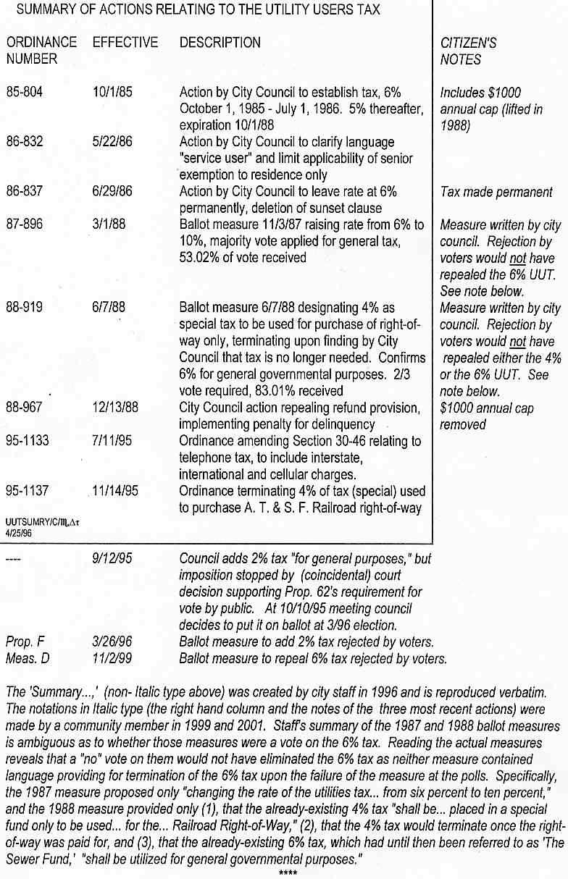
The info above, downloaded 5-27-15 from noutilitytax.com/History.htm, did not include these later actions:
2007: City-sponsored Measure H, billed as a tax reduction, reduced part of the UUT to 5-1/2% but extended its reach to include "new communication technologies."
2009: At its 10-27-09 meeting the council backed away from a decision to hire a consultant for a new $9 million sewer tax.

